Sid Bhatia

MGT451

Professor Suchow

7 September 2023

**Lecture #1 Notes – On Predicting the Future**

*Delta t Argument, Problem Statement*

* The current time is *tnow*.
* Events have a beginning *t­begin*, and an end, *t­end*.
* We know *tnow* and *tbegin*, but not *tend*.
* Our goal is to predict *tend*.
* Example:
  + Prince Charles Reign

*Delta t Argument, Setup*

* By the **Copernican principle**, there’s no reason to believe we’re special.
  + We don’t know anything about the history of the world.
  + We are a randomly selected (sentient) observed.
* i.e., *tnow* could be anywhere in the interval *tbegin* to *tend*.
* We can formalize that uncertainty as a **uniform distribution** over the interval.
  + 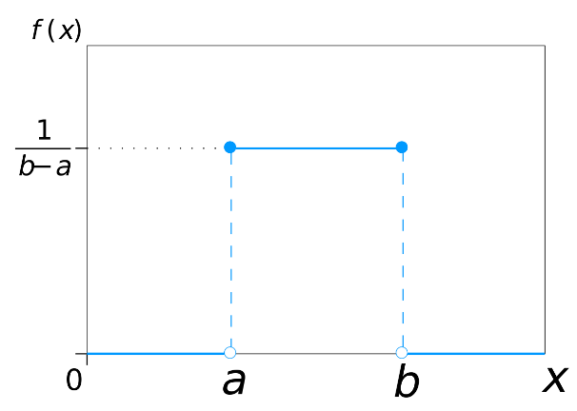
* What decision rule, based on *tnow* and *tbegin* will produce the most accurate estimate of *tend*?
* We assume we are at the **midpoint of the event**, therefore the endpoint will be the double the current time.

*Optimal Predictions in Everyday Cognition*

* Say we come across a person who is 20 years old.
* How long will they live? Apply the delta t argument: only know *tbeing* and *tnow* 🡪 40 years
* What went wrong?

*Bayes’ Theorem*

* 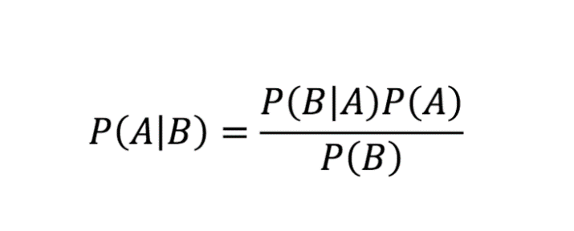
* Prior, data (likelihood), posterior
  + Combine prior with data 🡪 posterior.
* **P(ttotal | t) = P(t | ttotal) * P(ttotal)**
* Vertical axis of continuous distribution = probability mass
  + Avoid putting numbers on vertical axis due to difficulty maintaining axiom of probability where summation of all probabilities equal to 1.

*Recency Illusion*

* Between you and I
* c.f. the high five
* Belief of things you’ve noticed recently are recent.